An account has been created for you in Schoology, all you have to do is log in!
To help you get started, you have already been enrolled in your Courses.

What Do I Need to Setup in Schoology?
- Setup your User Profile
- Navigate to your Courses
- Check your Grades
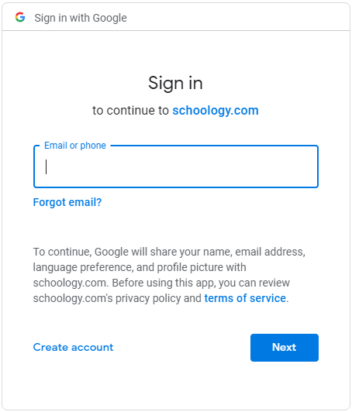
- Understand the Homepage: (Updates, Recent Activity, Calendar)

How Do I Log Into My Account?
You can log into your account following these steps:
- In your browser, navigate to our domain, https://mpsk12alus.schoology.com/
- Enter your MPS Google credentials.
Username: S#@stu.mps-al.org
Password: Last 4 of SS# twice. Example: 12341234

How Do I Learn More About How To Use Schoology?
To learn more, you can:
- Visit Schoology Support to access Schoology Help Guides.
- Contact your teacher.
- To report any issues with utilizing Schoology, please post in the “Schoology Student Assistance” Group. Please join this group using Access code: J487-5T55-5K3QD.

